Counterfactual Thinking and Need for Cognition: Appointing Blame

Former Student
Florida International University

Counterfactual Thinking and Need for Cognition: Appointing Blame
As free-willed beings, humans are often the victims of their own decisions. Imagine accidentally running over a stray cat because you decided to look away from the road at the exact moment the cat decided to cross the street. Following the accident, most people would be plagued with thoughts of how alternative circumstances or decisions could have prevented such an unfortunate situation. Every time an individual forms a ‘what if’ scenario in which he or she mentally alters the course of events occurred, they are participating in a process that is known as counterfactual thinking (Ruiselová et al., 2007; Williams et al, 1996). This process allows individuals to consider the multiple factors at play in a situation (i.e mutability), and to decide what specific condition was responsible for the ultimate outcome of the event. The primary focus of our study is to analyze the extent of culpability people place on a particular factor depending on the preventability of the outcome. That is, if it is easy to “undue” an event that ends in a tragic outcome, will participants find an actor who fails to engage in that easy behavior more at fault?
The development of counterfactual thoughts relies on the variability of the situation as well as the knowledge that different actions could have resulted in alternate outcomes (Alquist et al., 2015). According to Alquist et al., situations that are believed to be highly changeable generate more counterfactual thoughts than events that seem unavoidable. However, ruminating on every conceivable alternative of a situation would take an unlimited amount of time and resources. Instead of allotting so much time and energy on a cognitive task, people tend to narrow down the different scenarios that come to mind according to the degree of controllability of the factors involved (McCloy & Byrne, 2000). For example, the deliberate decisions individuals make that ultimately lead to a certain outcome is considered to be a controllable event, whereas uncontrollable events are unavoidable circumstances, such as traffic jams or natural disasters (McCloy & Byrne, 2000). As McCloy and Byrne note, when mentally forming a scenario different than the one occurred, individuals tend to change controllable rather than uncontrollable events. Therefore, events that are within an individual’s jurisdiction generally receive the brunt of the blame for the resulting situation.
In a similar light, a study performed by McCloy and Byrne (2000), discovered that inappropriate events are more often changed through the process of counterfactual thinking than appropriate ones, especially when the outcome of these events was negative. Inappropriate events include the decisions individuals make that are considered to be ‘socially wrong’, whereas appropriate events are ‘socially acceptable’ actions. Due to these results, we can conclude that what McCloy and Byrne consider to be “inappropriate controllable” events, will likely be regarded as highly culpable factors in the outcome of a situation.
Another contributing factor to perceived culpability is the extent of knowledge of the actors involved in an event, as well as the intent of their actions (Gilbert et al., 2015). For example, in the aforementioned scenario, had the driver known that looking away from the road would have caused her to run over the stray cat, the driver would have been more likely to be perceived guilty, even though the actions and the outcome of the situation remained the same. This rationalization is the product of a bottom-up method of thinking in which individuals are able to generate more counterfactual thoughts due to the actor’s knowledge of the outcome (Gilbert et al., 2015). As these authors have noted, the increased development of counterfactual thoughts will in turn attribute more responsibility to the actor, which will ultimately increase perceived blame. But this is not the full picture when it comes to focusing on the role of counterfactual thoughts in altering participant responses.
Study One
In pursuance of counterfactual thinking and its relationship to perceived blame, we devised a study that analyzed the extent of culpability people place on a particular factor depending on the preventability of the outcome. We provided participants with one of three scenarios, each of which depicted a variation of the same situation where alternate events lead to different conclusions. In the changeable condition, an actor engaged in a behavior that led to an undesirable outcome (death) that could have been avoided had he acted differently. In the unchangeable condition, the same actor engaged in a behavior that once again led to an undesirable outcome, but here the outcome could not have been avoided if he acted differently. In the neutral condition, the actor engaged in an alternative behavior, but the outcome was still undesirable. We predicted that participants would place more blame on the actor in the changeable condition where the actor could have avoided the undesirable outcome had he behaved differently than in both the unchangeable and neutral conditions, where the actor’s behavior could not be altered. This is because we expected changeable participants to generate more counterfactuals (more statements about how the actor could have behaved) in the changeable condition.
Methods
Participants
One hundred and twenty six students from Florida International University were randomly selected to participate in our study. Of these 126 participants, 37% (n = 47) were male and 63% (n = 79) were female. Ages ranged from a minimum of 17 to a maximum of 58 with an average of 22.32 years (SD = 6.30). The sample population consisted of 68.3% Hispanic Americans (n = 86), 8.7% African Americans (n = 11), 19% Caucasians (n = 24), 1.6% Asians (n = 2), and 2.4% who did not specify their ethnicity (n = 3). See Table 1.
Table 1
Demographics – Study One
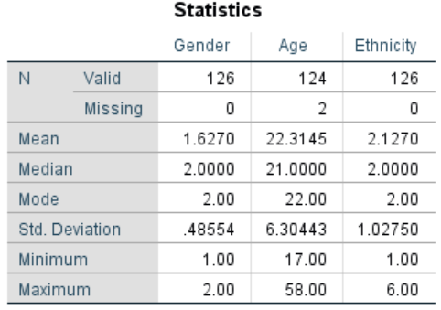
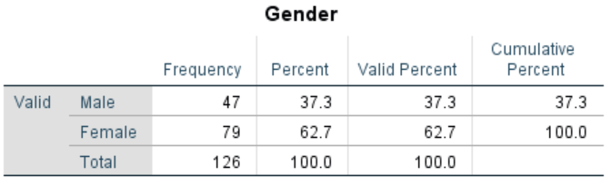
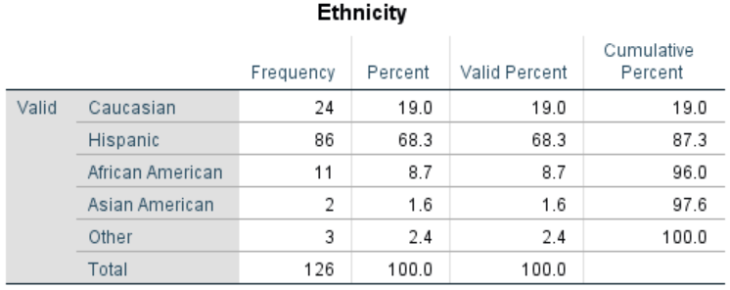
Materials and Procedure
In accordance with the standardized guidelines for informed consent, prospective participants were notified of the potential risks and benefits of participating in the study before being introduced to the research material. If the student verbally agreed to participate, he or she was given one of three different documents, each of which consisted of four parts or sections. In part one of the study, the participant read a short scenario concerning a paraplegic couple, Tina and Eugene, who requested a taxi for a night out with friends. Each of the three documents depicted the same initial situation with alternate conditions (changeable, unchangeable, or neutral).
In the changeable condition, the taxi driver arrived to pick up the couple, only to promptly decline their fare upon seeing that they were both paraplegic. Without enough time to call for another taxi, Tina and Eugene decided to take Tina’s car, which was handicap equipped. In order to reach their destination, they had to cross a bridge that had been weakened the night before due to a severe storm. The damaged bridge collapsed mere minutes before the couple reached it. Unable to see the missing portion of the bridge in the night, Tina and Eugene drove off the road, into the river below, and drowned. The taxi driver, who had left 15 minutes earlier, managed to make it safely across, before the collapse. In the unchangeable condition, the situation remained mostly the same with the exception that the taxi driver arrived at the bridge after it had collapsed and plummeted into the water as well. He managed to make it out of the car and swim to safety, but Tina and Eugene drowned. In the neutral condition, the taxi arrived to pick up the couple but promptly refused their fare as soon as he realized that they were both paraplegic. In this condition, the taxi driver did eventually agree to take Tina and Eugene to their destination downtown, albeit after much argument. Due to the recently collapsed bridge, the taxi driver drove his passengers and himself off the road and into the river below. He barely managed to make it out of the car before drowning. Tina and Eugene’s outcome remained the same.
After reading one of the scenarios described above, the participant continued on to the remainder of the study, which was composed of a series of open, partially open, and close-ended questions.
In part two, the student participating in the study was asked to procure as many ‘If Only’ statements as possible, meaning that they had to list all the factors they could think of that could have possibly changed the outcome of the event.
In part three, the participant was presented with a series of questions about their thoughts regarding the specific situation they read about. After reading each question, the participant was asked to record his or her response in a scale of one to nine. These questions included how avoidable they thought the accident was (1 = not at all avoidable, 9 = very avoidable), the causal role of the taxi driver in the couple’s death (1 = not at all causal, 9 = the most important cause), their thoughts on how much control the taxi driver had (1 = no control, 9 = complete control), the negligence of the taxi driver (1 = not at all negligent, 9 = completely negligent), how much money for damages the taxi driver was responsible for (1 = no money, 9 = as much as possible), the foreseeability of the couple’s death (1 = not at all foreseeable, 9 = completely foreseeable), and how much blame the taxi driver deserved for the event (1 = no blame at all, 9 = total blame). Remaining questions focused on a series of statements about the taxi drive, all rated on scales ranging from 1 (Strongly Disagree) to 9 (Strongly Agree). These statements included, “The taxi driver was reckless”, “the taxi driver was patient”, “The taxi driver was careful”, and “The taxi driver was hasty”. The last question of part three was a yes or no question that asked the participant whether the taxi driver agreed to drive the couple or not. This final question served as an attention check, which informed us if the participant was attentive to the study and allowed us to exclude potentially misrepresentative responses from our data.
Part four asked for the participant’s demographic information, including gender, age, ethnicity, their first language, and whether they were a student at Florida International University. Concluding the study, the participant was debriefed on his or her contribution to the study as well as our insights on counterfactual thinking and our main hypothesis.
Although we had several dependent variables, our primary focus involved the perceived blameworthiness of the taxi driver, the number of ‘If Only’ statements the participants could create, and the manipulation check regarding whether the driver agreed to take the couple. As such, these are the only three dependent variables that we analyzed.
Results
Using survey condition (changeable vs. unchangeable vs. neutral) as our independent variable and whether participants recalled whether the taxi driver picked up the paraplegic couple as the dependent variable, we ran a manipulation check in which we saw a significant effect, X²(2) = 93.95, p < .001. Participants in the changeable and unchangeable conditions correctly said the taxi did not pick up the couple (95.2% and 90.5%, respectively) while few participants in the neutral condition said the driver picked up the couple (4.8%). Cramer’s V, which is most appropriate for a 3 X 2 chi square, showed a large effect. This indicates that participants did pay attention to whether the taxi driver picked up the couple. See Table 2.
Table 2
Crosstabs and Chi Square – Study One
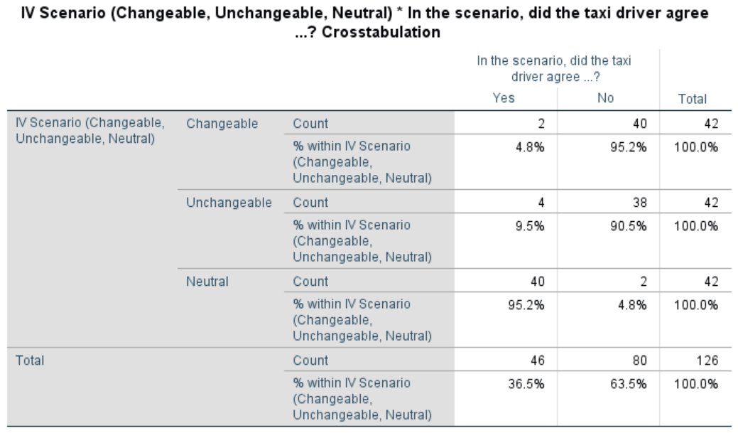
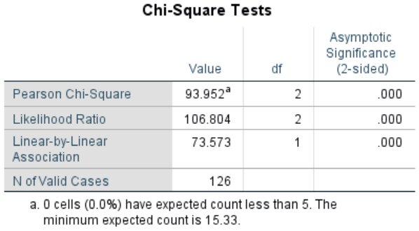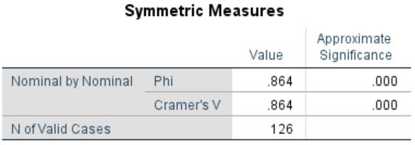

For our main analysis, our first One-Way ANOVA test revealed significant differences among our independent variable, the scenario conditions (changeable, unchangeable, or neutral) and our dependent variable, perceived blameworthiness of the taxi driver, F(2, 122) = 3.55, p = .032. A subsequent Tukey post hoc test supported our hypothesis by demonstrating that participants were more likely to blame the taxi driver in the changeable condition (M = 4.51, SD = 2.06) than in the unchangeable condition (M = 3.38, SD = 2.14).. However, there were no significant difference for perceived blame between the neutral condition (M = 4.36, SD = 2.11) and either the changeable or unchangeable conditions. These results indicate that in situations where the outcome is perceived as mutable (changeable), individuals are more likely to assign blame to the actor who could have acted differently (unchangeable). See Table 3.
Table 3
ANOVA Blame – Study One
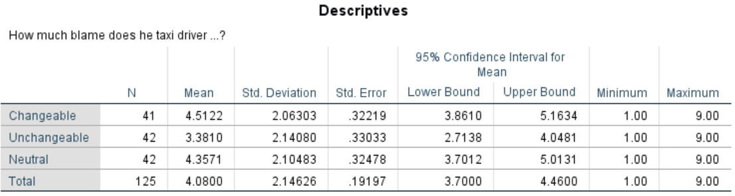
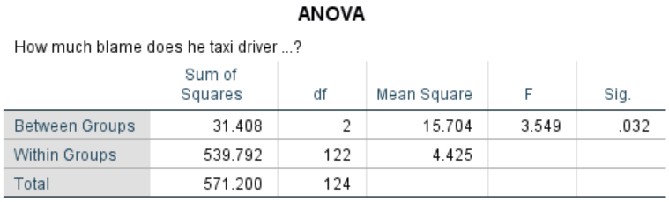
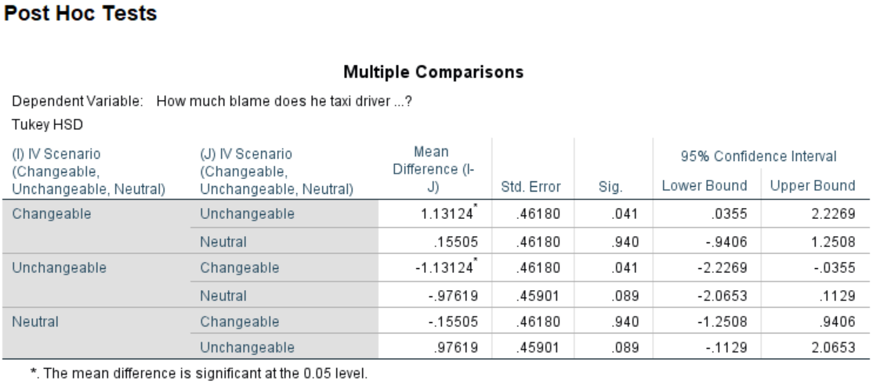
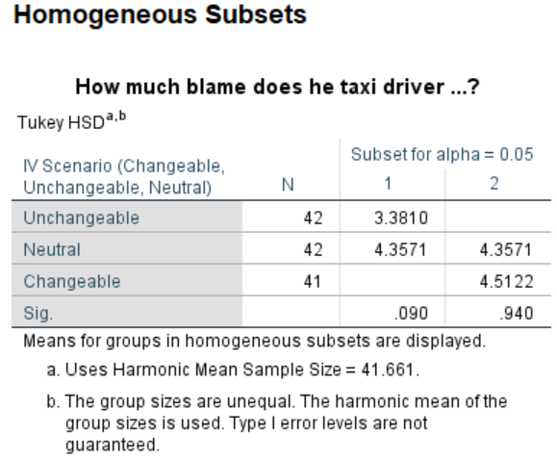
We were also interested in the number of ‘If Only’ statements generated for each condition. We ran a One-Way ANOVA test using the different conditions (changeable, unchangeable, or neutral) as our independent variable, and the number of counterfactuals produced as our dependent variable. The results revealed that the relationship between condition and number of ‘If Only’ statements produced was not significant, F(2, 123) = 1.79, p = .171. Our initial prediction that participants would develop more counterfactuals in the changeable condition was not supported since the number of counterfactuals generated in the changeable condition (M = 5.41, SD = 2.21), the unchangeable condition (M = 4.57, SD = 2.04), and the neutral condition (M = 4.88, SD = 1.85) did not differ. Since the p-value for the ANOVA test was not significant, there was no need to run post hoc tests. See Table 4.
Table 4
ANOVA Number of Counterfactuals – Study One
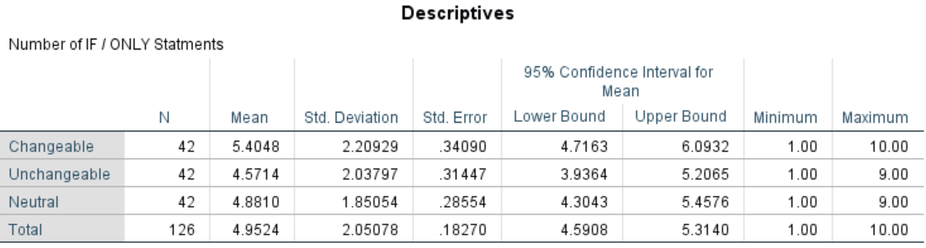
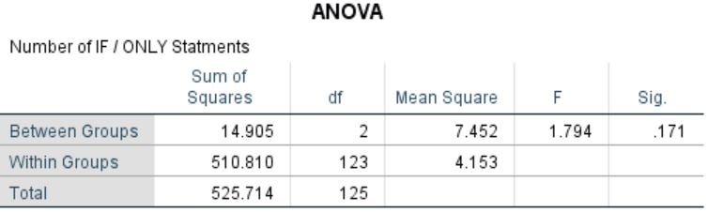
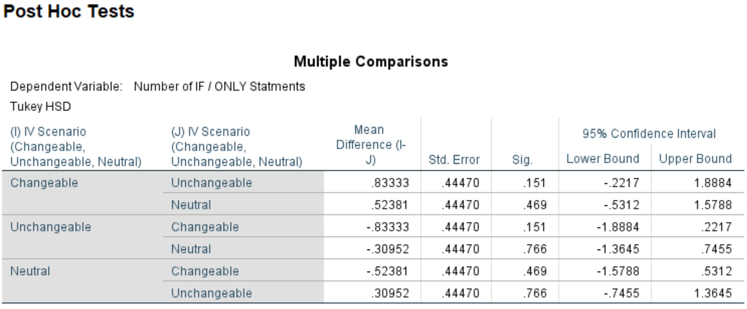
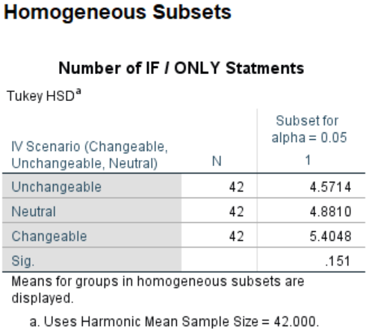
Finally, we ran an independent samples t-Test with the changeable and unchangeable conditions only and “How avoidable was the accident” as the dependent variable, which was significant, t(82) = 2.71, p < .01. Participants thought the accident was more avoidable in the changeable condition (M = 5.31, SD = 1.77) than in the unchangeable condition (M = 4.21, SD = 1.85). See Table 5.
Table 5
t-Test “Was the accident avoidable?” – Study One
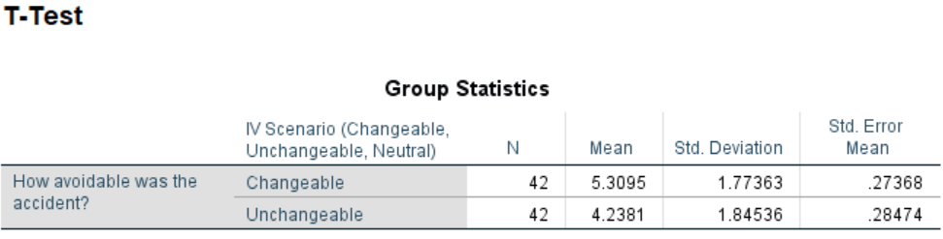
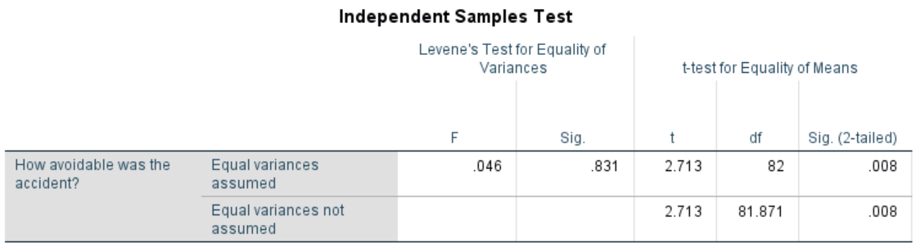
Discussion
We predicted that participants would place more blame on an actor whose behavior led to an undesirable outcome (death) when that actor could have acted differently primarily because these participants would generate more “If Only” counterfactual statements that would lead them to see the outcome could have been avoided. Conversely, we predicted that participants who read about an undesirable outcome that could not have been avoided would assign less blame to the actor and would think of fewer counterfactual “If Only” statements. Results partially supported these predictions, as we did find more blame for in the changeable condition compared to the unchangeable (though neither differed from the neutral condition), and they thought the accident was more avoidable in the changeable condition than in the unchangeable condition. However, the number of counterfactual statements that participants generated did not differ among our three conditions. It could be that participants were unfamiliar with the counterfactual task, which requires some deep thinking, though on a more unconscious level they could have seen the changeable condition as evidencing more elements of blame. This begs the question: what if participants were forced to think deeper? This is the focus of our second study.
Study Two
Although most of the general population engages in counterfactual thinking, the number of counterfactual thoughts created varies between people. This is because the development of numerous counterfactual thoughts is determined by the overall mutability of a situation as well as the distinct differences between individuals (Alquist et al., 2015). For example, people who have an inclination for structuring situations in meaningful, integrated ways, or more aptly put, have a high need for cognition, are more prone to elaborate on presented information (Cacioppo & Petty, 1982). Therefore, these individuals might be more likely to participate in the generation of counterfactual thoughts than individuals who typically avoid effortful cognitive activity, or have a low need for cognition (Sargent, 2004). Despite the fact that several studies have researched scenario mutability and need for cognition, no prior findings have examined the influence these two variables have on the assignment of blame. The primary focus of our second study, therefore, is to analyze the extent of culpability people place on a particular factor depending on the mutability of the situation as well as the distinct Need for Cognition of each subject.
Need for Cognition (NFC) is defined as an individual’s dispositional tendency to participate in demanding cognitive behaviors (Curseu, 2006). People with a high-NFC tend to enjoy engaging in cognitive endeavors and generally undergo a deep elaboration of information (Strobel et al., 2015), while individuals with a low-NFC use cognitive heuristics and often rely on others’ opinions (Furnham & Thorne, 2013). Petrocelli and Dowd (2009) proposed that individuals with a high-NFC employ complex attributional systems that allow them to think theoretically and recognize situational elements as causes of behavior. For example, in the previously mentioned scenario, people with a high-NFC are likely to consider the external or environmental aspects—such as distracting traffic—as blameworthy factors in the unfortunate, accidental death of the stray cat. According to Curseu (2006), individuals with a high-NFC also tend to generate more alternative solutions to problems compared to low-NFC individuals who tend to avoid strenuous cognitive activities (Petrocelli & Dowd, 2009). Taking these components into account, it is reasonable to expect high-NFC subjects to produce more counterfactual thoughts than low-NFC subjects.
Considering the distinct attributes of individuals with a high and low NFC, it is highly probable that attitudes towards judgments of blame are significantly different between the two conditions (Sargent, 2004). According to Sargent (2004), people with high-NFC usually prefer to tackle social problems involving crime rather than actually punishing the criminal responsible. This might be due to the complex attributional systems used by high-NFC individuals, which attributes behavior to “abstract, contemporary, external causes” and ultimately withdraws responsibility from the perpetrator and places it on societal influences instead (Sargent, 2004). Therefore, it is not surprising that Sargent found a negative correlation between high-NFC and punitive responses to crimes, since high-NFC individuals tend to view the criminal as a victim of circumstantial events. However, Sargent also notes that understanding the consequences of a criminal act through exposure to particular criminal cases can cause high-NFC individuals to think more about the consequences of a committed crime, which in turn might result in a positive correlation between high-NFC and punitive reactions to criminal acts. Thus, whether a high-NFC individual finds a perpetrator blameworthy or not depends on the specific details of the crime, and the resulting consequences of the events occurred.
On a related note, an experiment conducted by Wevodau et al. (2014) investigated the correlational interaction between NFC and perceived blame. According to Wevodau et al., there is a substantial positive association between NFC and the allocation of blame. The researchers found that that highly motivated individuals who enjoy effortful cognitive processing tend to assign more culpability than cognitively reserved individuals.
In pursuance of scenario changeability and NFC, study two analyzed the extent of culpability placed on a particular factor depending on the mutability of the situation as well as the distinct need for cognition of each subject. In order to manipulate NFC in our study, we presented participants with a set of high-NFC and low-NFC statements and asked them to agree somewhat with each statement in reference to themselves. We then provided participants with the same taxi scenario used in study one, though we dropped the neutral condition since it provided results nearly identical to the unchangeable condition.
We have two main analyses in the present study, each of which examines two main effects and one interaction for each of our main dependent variables (number of counterfactuals and level of blame). When it comes to our first dependent variable, the number of counterfactual statements generated in study two, we predicted a main effect for NFC such that participants high in NFC generate more counterfactuals than those low in NFC. We did not, however, predict a main effect of condition. Study one showed that participants generated a similar number of counterfactuals in both the unchangeable and unchangeable conditions, and thus we do not expect to see differences in study two. However, we did predict an interaction for number of counterfactuals generated. That is, we expected participants high in NCF in the changeable condition to generate the most counterfactuals since the outcome was more changeable! Participants in remaining conditions (high NFC unchangeable, low NFC changeable, and low NFC unchangeable) should generate comparable levels of counterfactuals.
For our second dependent variable, blame, we predicted a main effect for condition such that those in the changeable condition should find more blame than those in the unchangeable condition. This follows from study one, where participants blamed the taxi driver more when his cab made it safely across the bridge than when he passed safely. We also predicted a NFC main effect for blame wherein those high in NFC would find more blame than those low in NFC. That is, thinking deeply about the accident might elevate blameworthiness assessments compared to thinking shallowly. More important, we predict an interaction of condition and NFC on blame such that participants find the taxi driver more blameworthy in the high NFC and changeable condition compared to all other conditions. Low NFC and unchangeable participants should produce the lowest levels of blame.

References
Alquist, J. L., Ainsworth, S. E., Baumeister, R. F., Daly, M., & Stillman, T. F. (2015). The making of might-have-beens: Effects of free will belief on counterfactual thinking. Personality and Social Psychology Bulletin, 41(2), 268-283. doi:
10.1177/0146167214563673
Cacioppo, J. T., & Petty, R. E. (1982). The need for cognition. Journal of Personality and Social
Psychology, 42(1), 116-131. doi: 10.1037/0022-3514.42.1.116
Cacioppo, J. T., Petty, R. E., & Kao, C. F. (1984). The efficient assessment of need for
cognition. Journal of Personality Assessment, 48(3), 306-307. doi: 10.1207/s15327752jpa4803_13
Curseu, P. L. (2006). Need for cognition and rationality in decision-making. Studia
Psychologica, 48(2), 141-156.
Gilbert, E. A., Tenney, E. R., Holland, C. R., & Spellman, B. A. (2015). Counterfactuals, control, and causation: Why knowledgeable people get blamed more. Personality and Social Psychology Bulletin, 41(5), 643-658. doi: 10.1177/0146167215572137
Furnham, A., & Thorne, J. D. (2013). Need for cognition: Its dimensionality and personality and
intelligence correlates. Journal of Individual Differences, 34(4), 230-240. doi: 10.1027/1614-0001/a000119
McCloy, R., & Byrne, R. M. J. (2000). Counterfactual thinking about controllable events. Memory & Cognition, 28(6), 1071-1078. doi: 10.3758/BF03209355
Petrocelli, J. V., & Dowd, K. (2009). Ease of counterfactual thought generation moderates the
relationship between need for cognition and punitive responses to crime. Personality and
Social Psychology Bulletin, 35(9), 1179-1192. doi: 10.1177/0146167209337164
Ruiselová, Z., Prokopčáková, A., & Kresánek, J. (2007). Counterfactual thinking in relation to the personality of women--doctors and nurses. Studia Psychologica, 49(4), 333-339.
Sargent, M. (2004). Less thought, more punishment: Need for cognition predicts support for
punitive responses to crime. Personality and Social Psychology Bulletin, 30(11), 1485-1493. doi: 10.1177/0146167204264481
Strobel, A., Fleischhauer, M., Enge, S., & Strobel A. (2015). Explicit and implicit need for
cognition and bottom-up/top-down attention allocation. Journal of Research in Personality, 55, 10-13. doi: 10.1016/j.jrp.2014.11.002
Wevodau, A. L., Cramer, R. J., Clark, John W., I.,II, & Kehn, A. (2014). The role of emotion
and cognition in juror perceptions of victim impact statements. Social Justice Research, 27(1), 45-66. doi: 10.1007/s11211-014-0203-9
Williams, C. W., Lees-Haley, P., & Price, J. R. (1996). The role of counterfactual thinking and causal attribution in accident-related judgments. Journal of Applied Social Psychology, 26(23), 2076-2099. doi: 10.1111/j.1559-1816.1996.tb01789

